**LAB 7**

**(Assessment) Logic Check**

**Enter the following values by running Number.java after your modification and explain the behavior.**

**•1**

The program will output “1 character of the alphabet is B” because the user’s input is within the range.

**•20**

The program will output “20 character of the alphabet is U” because the user’s input is within the range.

**•1,000**

The program will output “Outside of range” because it’s greater than the range of 0-25.

**•500,000,000,000**

The program will not accept this input because it is out of the range of integers.

**•-500,000,000,000**

The program will not accept this input because it is out of the range of integers.

**•12,345**

The program will output “Outside of range” because it’s greater than the range of 0-25.

**•789.543**

We are comparing integers so the program will not accept this input because it is out of the range.

**•-0**

Outputs “A” because -0 is the same as zero.

**•Participation Activities**

**Activity 3.3.4**

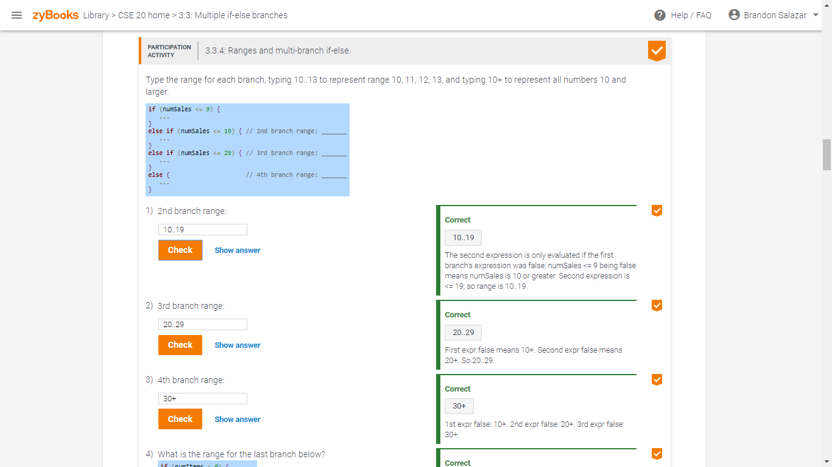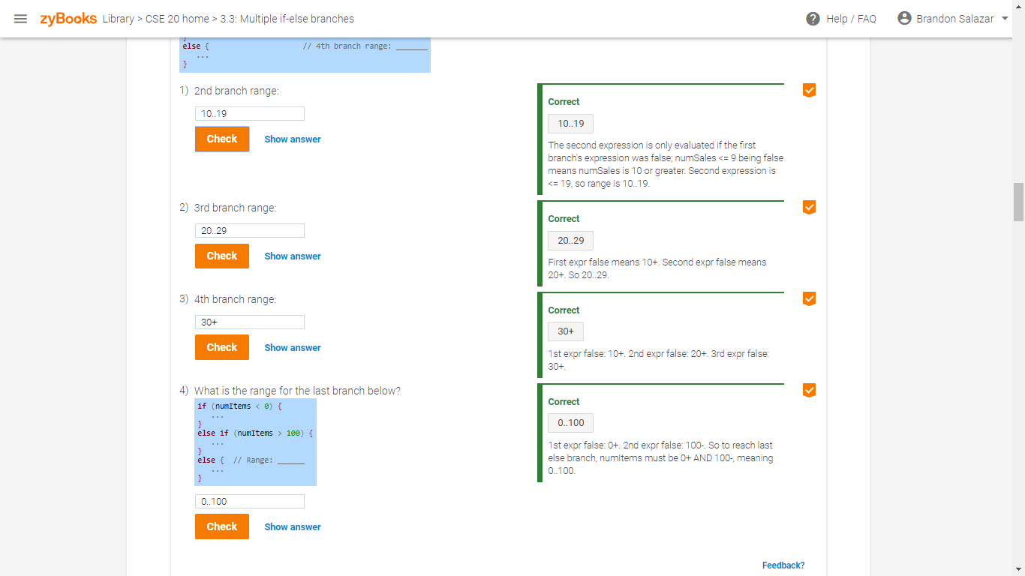

**Activity 3.3.5**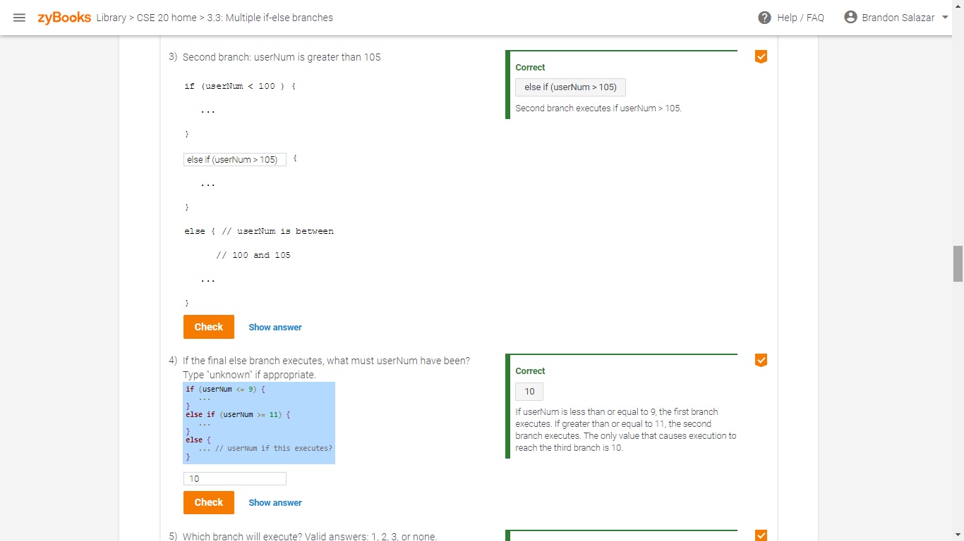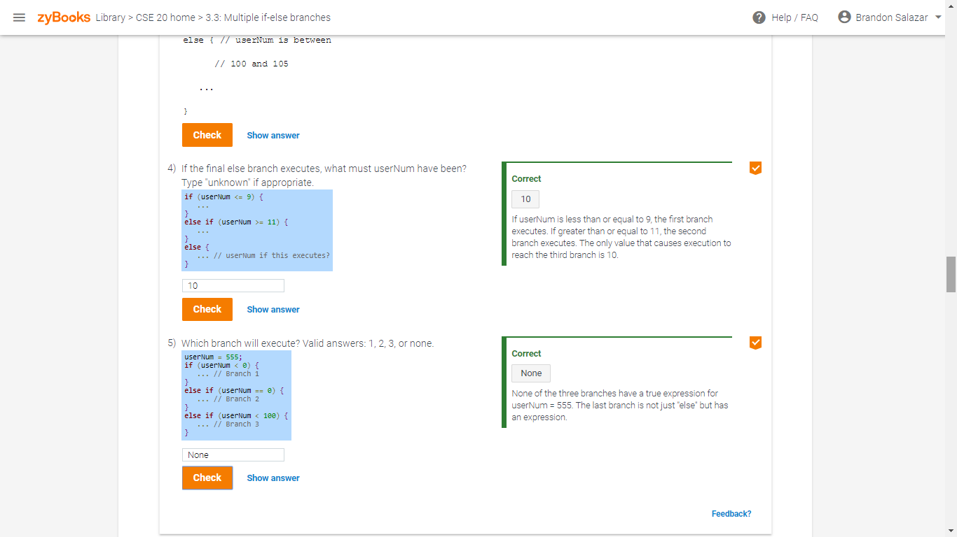

**Activity 3.4.1**

